Eventi
Use Case Specification

Submitted to:

Asst. Prof. Ma. Rowena C. Solamo
Faculty Member
Department of Computer Science
College of Engineering
University of the Philippines, Diliman

Submitted by:
Dimaano, Aaron Diego I.
Lopez, Matthew S.
Torres, Jacob Angelo V.

In partial fulfillment of academic requirements
for the course
CS 191 Software Engineering I
of the
1st Semester, AY 2015-2016
Unique Reference:
The documents are stored in https://github.com/Tom-2013-06417/CS191-192_Event_Sharing/tree/master/02-Requirements%20Engineering.
Link to this document: https://github.com/Tom-2013-06417/CS191-192_Event_Sharing/blob/master/02-Requirements%20Engineering/5.0%20-%20Collect%20user%20feedback.pdf.

Document Purpose:
The purpose of this document is to exhaust the step-by-step process of the Use Cases in every scenario possible.

Target Audience:
To our project client and adviser, our fellow 191 classmates, and our future selves when they need to refer back to this document.

Revision Control:

Revision Date | Person Responsible | Version  Number | Modification
09/18/15 | Dimaano, Diego  Lopez, Matthew  Torres, Jacob | 1.0 | Initial Document

Use-Case Name: Collect user feedback

Description: If a user submits feedback, there has to be someone ready to collect it so that it may be acted upon. Related to reporting content, this helps improve the site’s environment while improving its other functionalities.

Preconditions: There is an internet connection to the Eventi server and a device with browsing capabilities. Users must have sent feedback. An Administrator must be logged in to the site perform such tasks.

Flow of Events:

Scenario Name | Description
Scenario 1 (Basic Flow)  Collect Feedback | 1. Users send feedback  2. System collates the feedback into a presentable form  3. System presents the feedback in the administrative panel  4. Administrators can view these feedback on the administrative panel

Activity Diagram of the Flow of Events:

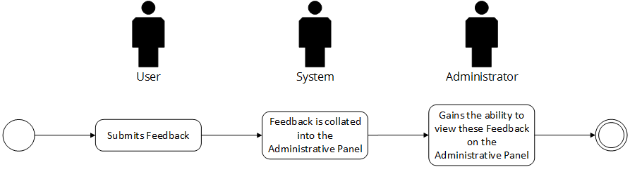

Post-conditions: Successful: The feedback was successfully submitted and the Administrator can see the responses
Failed: The feedback failed to submit.

Special Requirements: NONE

